Trigger is a piece of code that gets executed on a DML or DDL event

Uses of Triggers
- Cascade changes through related tables in a database
- Reject changes that violate referential integrity
- Apply validations that are too complex
- Enforce complex restrictions than those defined with CHECK constraints
- Find the state of a table before and after data modification

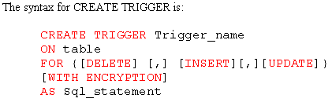

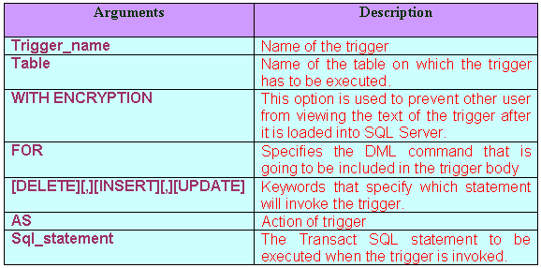
Inserted & Deleted Tables

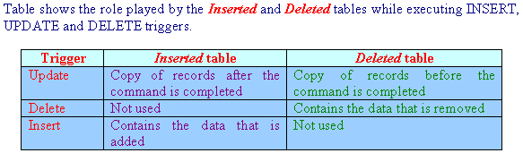
Examples of Triggers

CREATE TABLE TAB1(A INTEGER);
CREATE TABLE TAB2(B INTEGER);
CREATE TABLE TAB3(C INTEGER);

Example 1 -- Inserted row from tab1 should also get inserted in table tab2

create trigger trig1
on tab1
for insert
as
begin
insert into tab2
select * from Inserted
end

insert into tab1 values(100);
select * from tab2;

Example 2 -- Deleted row from tab1 should get inserted in table tab3

create trigger trig2
on tab1
for delete
as
begin
insert into tab3
select * from Deleted
end

delete from tab1 where a = 100
select * from tab3

Example 3 – If the new value inserted is < 100 then the record should not be inserted.(Conditional Insert)

create trigger trig3
on tab4
for insert
as
begin
if (select a from inserted) < 100
begin
Print 'Value cannot be less than 100'
Rollback Tran
end
end

insert into tab1 values(99) -- Throws error

Example 4 – To show how inserted and deleted tables of trigger work with Update statement

create trigger trig4
on tab1
for Update
as
begin
select 'Showing the updated values'
select * from inserted
select 'Showing the old values'
select * from deleted
end

Insert into tab1 Values(101);

select * from tab1;

update tab1
set a = 1000
where a = 101; (Note – See the Results in Text)

Instead Of Triggers
In case of instead of triggers, the code contained inside the triggers gets executed in place of the original data manipulation statement.

When a record is tried to insert in emp_performance table then instead of record getting inserted the system date and time should get inserted in check_inserts table.

create table Emp_Performance(empid integer, sales integer, profit integer, loss integer);
insert into emp_performance values(1,7000,300,120);
insert into emp_performance values(2,18000,7000,15);

create table CHECK_INSERTS(username varchar(20),dates varchar(30));

CREATE TRIGGER TRIG11
ON EMP_PERFORMANCE
INSTEAD OF INSERT
AS
BEGIN
INSERT INTO CHECK_INSERTS
VALUES(user, getdate() )
Print 'Cannot insert record'
END

insert into emp_performance values(3,6000,90,6)
select * from check_inserts
select * from emp_performance

Directly DML cannot be done on a view based on more than one tables. But using Instead of triggers it is possible.

Create table s(roll integer, name varchar(40));
Insert into s values(1,'A');
Insert into s values(2,'B');
Insert into s values(3,'C');
Insert into s values(4,'D');

create table r(roll integer,marks integer);
Insert into r values(2,90);
Insert into r values(3,98);

create view sr
as
select s.roll,s.name,r.marks
from s,r
where s.roll = r.roll;

insert into sr values(5,'z',80);

create trigger trig12
on SR
INSTEAD OF INSERT
as
begin
insert into s
select roll,name
from Inserted
insert into r
select roll,marks
from inserted
end

insert into sr values(5,'z',80);
select * from sr;
select * from s;
select * from r;

Combining all events in one trigger

Restricting DML on Sunday

create trigger trig11
on emp
for insert,delete,update
as
Begin
declare @v_day varchar(20)
select @v_day= datename(dw,getdate())
if @v_day = 'Sunday'
begin
print 'No Transactions on Sunday'
rollback tran
end
end

Procedure can be called inside a trigger

create procedure pr
as
Begin
print 'a'
End

create trigger tr
on tab3
for insert
as
begin
exec pr
end

insert into tab3 values(102)

DDL Triggers (New from SS2005)

SQL Server 2005 has extended the trigger functionality you normally use with Data Manipulation Language (DML) commands such as INSERT, UPDATE, and DELETE to incorporate Data Definition Language (DDL) commands like CREATE DATABASE, DROP TABLE, and ALTER TABLE.

Also, like DML triggers, DDL triggers run in the same transaction as the DML statement. So for instance, when a DDL TSQL statement has completed, you can rollback a transaction whenever appropriate.
Unlike DML triggers, DDL triggers respond to completely different events. As previously stated, DDL triggers respond to changes to a database or a server. Each time DDL statements make changes using commands such as CREATE TABLE, an event is fired. DDL triggers can subscribe to those events and execute other TSQL instructions in response to the events.
Some other differences between DDL and DML triggers include the following:
- DDL triggers do not support the INSTEAD of functionality in the CREATE TRIGGER statement.
- DDL triggers are missing the inserted and deleted tables common to DML triggers.
Example – Preventing a user from dropping or altering any table.

Use master
Go
Create database ddl_trig_demo
Go
Use ddl_trig_demo
Go
Create table t1 ( a int)
go

create trigger tr1
on database
for drop_table, alter_table
as
PRINT 'WRONG'
ROLLBACK

Drop Table t1
go

sys.triggers and sys.trigger_events are the data

Event Data → Returns information about server or database events. EVENTDATA is called when an event notification fires, and the results are returned to the specified service broker. EVENTDATA can also be used inside the body of a DDL trigger.
EVENTDATA returns data only when referenced directly inside of a DDL trigger. EVENTDATA returns null if it is called by other routines, even if those routines are called by a DDL trigger.
Data returned by EVENTDATA is not valid after a transaction that called EVENTDATA, either implicitly or explicitly, commits or is rolled back.

EVENTDATA returns a value of type xml. The schema returned for each event is comprised of elements nested inside an <EVENT_INSTANCE> element. To obtain the schema returned for an event, use Index or Search to locate the topic for the event in SQL Server Books Online. The property names listed for the event correspond to elements returned in the schema, with the following exceptions:
- EVENTDATA returns a <ServerName> element, instead of <SQLInstance> and <ComputerName>.
- EVENTDATA returns an additional <EventType> element.

<EVENT_INSTANCE>
<EventType>type</EventType>
<PostTime>date-time</PostTime>
<SPID>spid</SPID>
<ServerName>name</ServerName>
<LoginName>name</LoginName>
<UserName>name</UserName>
<DatabaseName>name</DatabaseName>
<SchemaName>name</SchemaName>
<ObjectName>name</ObjectName>
<ObjectType>type</ObjectType>
<TSQLCommand>command</TSQLCommand>
</EVENT_INSTANCE>

Use ddl_trig_demo
Go
create trigger Get_Table_Name
On Database
For Create_Table
AS
PRINT 'CREATE TABLE Issued.'
SELECT EVENTDATA().value
('(/EVENT_INSTANCE/ObjectName)[1]','nvarchar(max)')

create table ts1 (a int)

Unlike DML triggers, DDL triggers are not scoped to schemas. Therefore, the OBJECT_ID, OBJECT_NAME, OBJECTPROPERTY, and OBJECTPROPERTYEX cannot be used for querying metadata about DDL triggers. Use the catalog views instead.

